**Continuous Monitoring**

We have a service level agreement (SLA) with Amazon Web Service (AWS), our IaaS/PaaS provider, to continuously monitor all our environments for performance and security.

All AWS EC2 instances are monitored using Cloudwatch metrics such as: CPU Utilization, Disk Reads and Writes, Network Usage (in and out (bytes)), and availability checks for the instances themselves. Alarms are configured to notify the administrator when CPU Utilization reaches and sustains 80% utilization, and also when the instance is unavailable. The following diagrams provide snapshots;

**Docker Container/instance graph using Datadog (CPU/memory/Disk)**

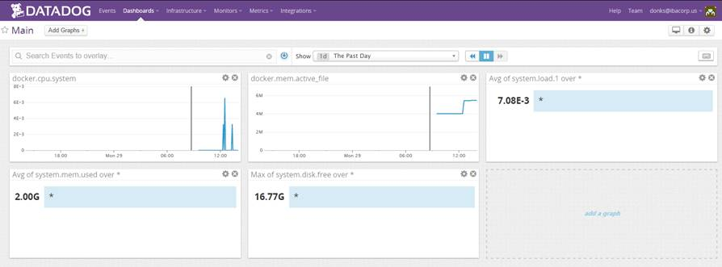

**AWS Cloudwatch monitoring**

